Logic Made Accessible Answer Keys
Lesson 1 Answer Key:
1) a. This is an argument: P1: Some penguins are black and white. P2: All old TV shows are black and white. C: Some penguins are old TV shows. b. This is an argument: P1: Symmetrical buildings are imposing. P2: The Taj Mahal is a symmetrical building. C: The Taj Mahal is imposing. c. This is not an argument since it cannot be reduced to a set of declarative sentences.
2) Answers may vary.
3) They are not. Even though such questions are used as a purely rhetorical device to imply that some statement or conclusion is very obvious or trivial, they are still not either true or false, so they are not part of our logic.
4) i.-d.; ii.-c.; iii.-a.; iv.-d.
5) a.,c.,e. are not declarative sentences; b. and d. are declarative sentences.
6) Assume that Alf is telling the truth. People who tell the truth are knights. Thus, Alf is a knight. Therefore, “Beth is a knave.” is a true sentence. Knaves are people who lie. Therefore, Beth is lying, so she is a knave. Therefore, “Neither Alf, nor I are knaves.” is a lie. Therefore, either Alf is a knight, or Beth is a knight, or both. But Beth is knave, so she cannot be a knight, so they cannot also both be knights. So we are right that Alf is a knight and Beth is a knave. Now assume Alf is lying. People who lie are knaves. Thus, Alf is a knave. Thus, “Beth is a knave.” is a lie. Thus, Beth is a knight. Knights are people who tell the truth. Therefore, “Neither Alf, nor I knaves.” is true. Therefore, both Alf, and Beth are knights. But Alf is a knave. Therefore, Beth is lying. Therefore, Beth is a knave. Therefore, “Neither Alf, nor I are knaves.” is a lie. Therefore, either Alf is a knight, or Beth is a knight, or both. But we have established that they are both knaves. We have arrived at a contradiction. Therefore, our assumption that Alf is lying cannot be the case. Therefore, Alf cannot be a knave. Therefore, Alf is a knight and Beth is knave.

Lesson 2a Answer Key:
Exercise 1
- Men, mortal
- The amazing man who won the world record, 50
- Man, predicated
- All countries that are greater than 50 square miles
- Aristotle, Plato’s pupil
Exercise 2
- This is not a term. Rather, it is an assertion that is either true or false. A term cannot be true or false.
- This is a term. It is simply a complex term, but it is neither a copula nor is it an assertion (it is neither true nor false).
- This is a term. It is neither a copula, nor is it an assertion (it is neither true nor false).
- This is not a term. Rather, it is two assertions that are either true or false. A term cannot be true or false.
- This is a term. It is neither a copula, nor is it an assertion (it is neither true nor false).
- This is a term. It is neither a copula, nor is it an assertion (it is neither true nor false).
- This is not a term. Rather, it is three assertions that are either true or false. A term cannot be true or false.
- This is a term. It is simply a complex term, but it is neither a copula nor is it an assertion (it is neither true nor false).
Exercise 3
Answers may vary. Any comparatives or superlatives are correct answers. For example: redder, slower, slowest, largest, smellier, smelliest, most perfect, more perfect, etc. Additionally, relational terms such as double, half, quarter, etc. are likewise correct.

Exercise 4
- syncategorematic; this term does not refer to a category of things
- syncategorematic; this term does not refer to a category of things
- categorematic; this term refers to the category “books” that contains all things which are books
- categorematic; this term refers to the category “the dog that is wagging its tail in front of me” that contains all things which are dogs that are wagging their tails in front of me.
- categorematic: this term refers to the category “Plato” that contains all things that are Plato. In other words, it has one member: Plato himself.
- syncategorematic; this term does not refer to a category of things
- categorematic: this term refers to the category “The United States” that contains all things that are The United States. In other words, it has one member: The United States itself.
- categorematic; this term refers to the category “happy things” that contains all things which are happy.

Lesson 2b Answer Key:
1.) Answers may vary. Our suggested definition is as follows: a proposition is whatever a declarative sentence expresses, and it can be either true, or false.
2.) A proposition is true if and only if its content describes an actual state of affairs in the world. A proposition is false if and only if its content does not describe an actual state of affairs in the world.
3.) i.-d.; ii.-a.; iii.-b.; iv.-c.
4.) a. is true; simplifies to “Philosophy is an academic subject.” its negation: “Philosophy is not an academic subject.” or “It’s not the case that philosophy is an academic subject.”
b. is false; its negation: “The sky is not green.” or “It’s not the case that the sky is green.”
c. is true; its negation: “Washington D.C. is not the capital of the United States,” or “It’s not the case that Washington D.C. is the capital of the United States.”
d. is false; its negation: “It’s not the case that it’s not the case that Europe is a continent.” or “It’s not the case that Europe is not a continent.” Both negations simplify to “Europe is a continent.”
5.) Answers may vary. Our suggested statement of double negation in the text is as follows: two negations result in an affirmation.

Lesson 2c Answer key:
1) Answers may vary. Lesson definition: a syllogism is a specific form of argument through which we infer a conclusion on the basis of two premises, each of which is a declarative sentence expressing a proposition; the two premises have exactly one term in common.
2) i. - d.; ii. - b.; iii. - a.; iv. - c.
3) a) invalid, unsound; b) invalid, unsound; c) valid, unsound; d) valid, sound.

Lesson 3 Answer key:
1) a) The predicate, ‘tall’, is denied of the subject, ‘trees’. b) The predicate, ‘wise’, is affirmed of the subject, ‘Socrates’. c) The predicate, ‘fluffy’, is denied of the subject, ‘my cat’. d) The predicate, ‘transparent’, is affirmed of the subject, ‘glass’. e) The predicate, ‘fun’, is affirmed of the subject, ‘logic’.
2) a) ‘pipe’ is an ambiguous term: The pipe is filled with tobacco. The pipe is leaking water. b) ‘large’ is a vague term. Answers may vary depending on the choice of sentence. c) ‘glass’ is an ambiguous term: Glass is obtained from sand. This glass is made of plastic. d) ‘water’ is neither vague, nor ambiguous. e) ‘long’ is a vague term. Answers may vary depending on the choice of sentence.
3) ‘cold’ is a good candidate. It’s an ambiguous term: ‘cold’ can refer to temperature or to illness. In the case of temperature, ‘cold’ is also a vague term: although we can independently measure temperature, what counts as actually being a member of the category “cold things” can have borderline cases.

Lesson 10 Answer Key:
Exercise 1
- “States” (with the term’s standard intension)
- “Days of the week” (with the term’s standard intension)
- “Fruits” (with the term’s standard intension)
- “Places” (with the term’s standard intension)
- “Pieces of furniture” (with the term’s standard intension)
- “Solar Bodies” (with the term’s standard intension)
- “Universities” (with the term’s standard intension)
- “Schools” (with the term’s standard intension)
Exercise 2
- (Answers may vary.) Correct answers are names of people in the classroom at the moment
- (Answers may vary.) New Year’s Day, MLK Day, Groundhog Day, Valentines Day, Easter Independence Day, etc.
- (Answers may vary.) George Washington, Abraham Lincoln, Theodore Roosevelt, Ronald Reagan, Barack Obama, etc.
- (Answers may vary.) Quadrilateral, Square, Rectangle, Pentagon, Hexagon, Heptagon, Octagon, etc.
- (Answers may vary.) Heptagon, Hexagon, Pentagon, Rectangle, Square, Trapezoid, Triangle, etc.
- (Answers may vary.) Math, English, Social Studies, Chemistry, Physics, etc.
- (Answers may vary.) My front yard, London, California, Mars, down the hall, etc.
- (Answers may vary.) New York, Denver, Appalachia, down the hall, Yellowstone National Park, etc.
- (Answers may vary depending on the city.)
Exercise 3
- Definition is too broad. If anything that was a featherless biped at a certain time was a human, then a plucked chicken would be a human (Diogenes’ counterexample to Plato’s definition of “man”).
- Definition is too narrow. Small children are under 50 pounds, and they are still human.
- Definition is too broad. There are many four-sided polygons that are not squares – many instances of rectangles, trapezoids, parallelograms, etc.
- Definition is too narrow. There certainly are squares with sides shorter than 10 inches.
- Definition is too broad. Ostensibly, there are boring things to study that aren’t math. For instance, most people would find an in-depth study of the back of one’s hand boring.
- Definition is too narrow. There are definitely types of food that have just cheese (no ham) between two pieces of bread that would be considered sandwiches. Under this definition, grilled cheese sandwiches would not be sandwiches.
- Definition is too narrow. If you don’t bring your backpack to school, it’s still a school. Likewise, schools don’t have to offer a place or time to eat lunch to be considered a school.
- Definition is too broad. There were many philosophers from Ancient Greece besides Aristotle.
Exercise 4
- The definition of “humans” given here is far too broad. There are many animals that are not humans.
- The terms are defined correctly here. As such, this is a sound argument.
- The definition of “computer” here is too broad. There are many types of electronic devices that are not computers.
- The definition of “country” here is too narrow. There are many countries which have a square area of less than 50,000 square miles.
Exercise 5
A categorematic term is simply a linguistic expression that can be neither true nor false and refers to a category. A category is a collection of particular things that share a common relevant property which is exclusive to those members. The intension of the term is a description of this common property that all members of the category share. The extension of the term is the totality of all of the members of the category in question.

Lesson 11 Answers Key:
Exercise 1-2
- Answers will vary widely, however any sentence in the form of an assertion will count as a correct answer for each of three propositions to be written down.
- Equally, answers will vary, however generally speaking, the answers will be correct if the noun preceding the verb is listed as the subject, the verb is the copula, and the adjective or noun following the verb is listed as the predicate.
Exercise 3

Subject | Predicate | Copula
_{Aristotle} | a thing that philosophized illustriously | _{is}
_{Pencils} | things that write in a neater fashion than pens | _{are}
_{These tables} | _{things that fall apart easily} | _{are}
_{Beethoven} | a thing that composed wonderful music | _{is}
_{Happiness} | _{a wonderful thing to have} | _{is}
_{Usain Bolt} | a thing that runs faster than any human in history | _{is}
_{Plato} | a thing that went to the gym last week | _{was/is}
_{I} | a thing that needs to eat some food | _{am}
_{A whole} | a thing that is greater than its part | _{is}
_{Being feared} | a thing better than being loved | _{is}
Exercise 3
1.) This is a proposition.
2.) This is not a proposition.
3.) This is not a proposition.
4.) This is a proposition.
Exercise 4
1.) These propositions do not mean the same thing; the student should not equate the property of being wonderful with the property of being wonderful-tasting. The student may, however, claim that for apples being wonderful implies being wonderful-tasting, due to the nature of value in this sense being dependent on human preference. If a well-conceived justification of this type is given, the student may say the propositions are identical.
2.) This is open for dispute, so a well-reasoned answer should receive full points. These Propositions mean the same thing under the assumption that one who has a good-character is good, and vice versa. The student may however disagree with this identification, if such a disagreement is explicitly stated and reasoned towards, the student may hold that the propositions are not identical.
3.) These propositions mean the same thing, since being the daughter of my father is equivalent to being my sister, and being kind implies being kind-hearted. The reverse also holds.

Lesson 12 Answer Key
Exercise 1
A category is a collection of things that have some sort of relevant commonality. The name of the category is almost always reflective of that commonality. For instance, the category “dogs” is the collection of all things that have the commonality of being a dog.
Exercise 2
- No mammals lay eggs – Universal Negative, false
- All mammals lay eggs – Universal Affirmative, false
- All humans are mammals – Universal Affirmative, true
- No humans lay eggs – Universal Negative, false
Exercise 3
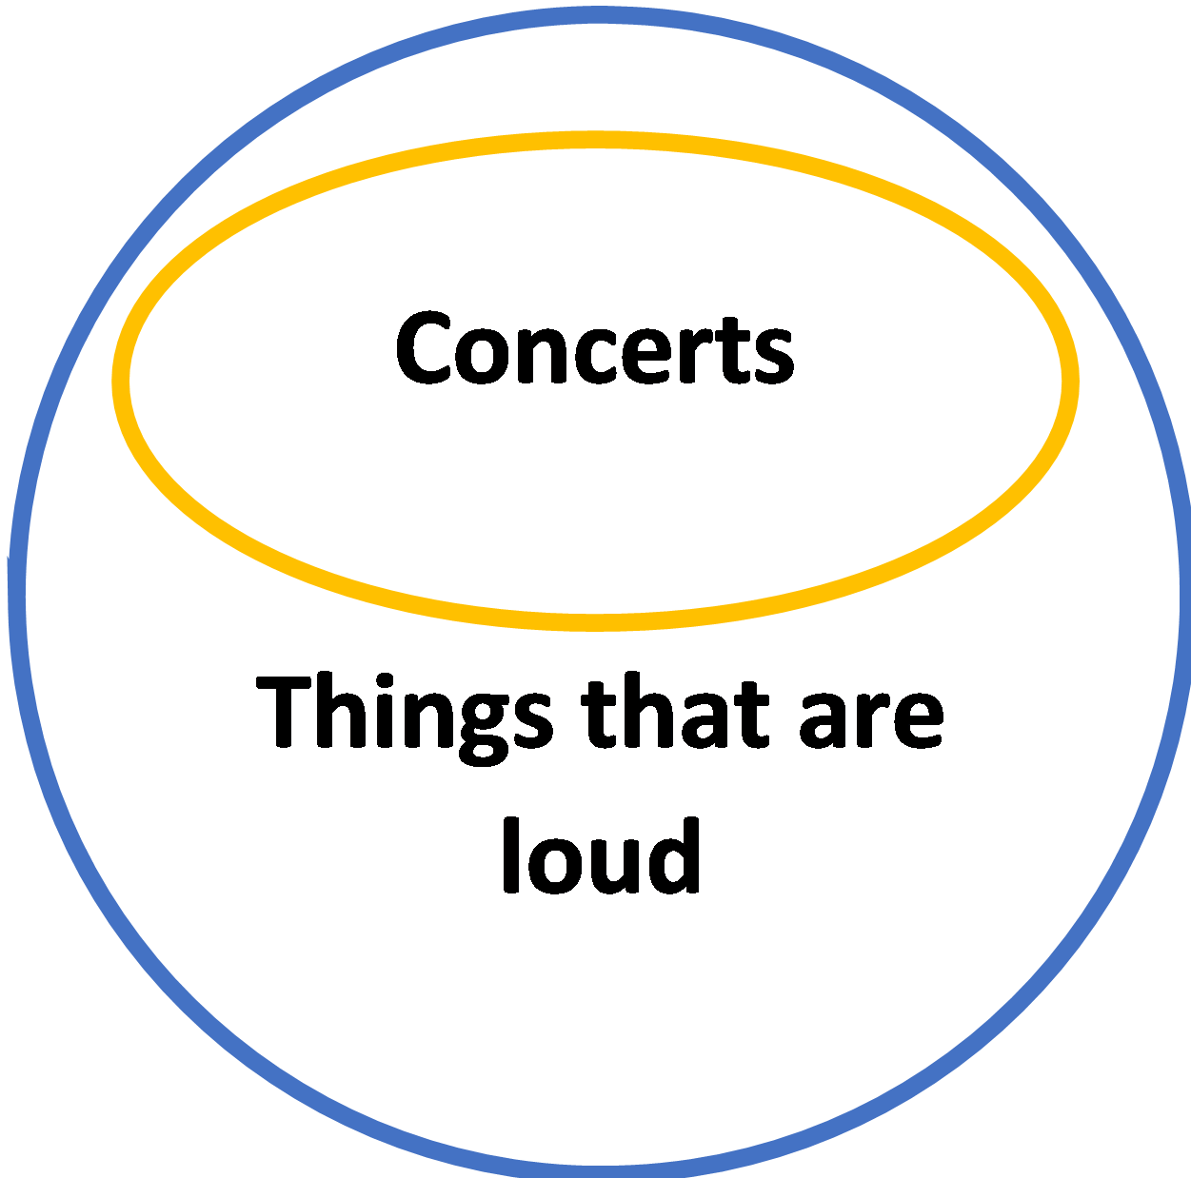
Euler Circles for “All concerts are loud” (answers may vary in terms of labelling)

Exercise 4
Answers will vary, but diagrams should look similar to the ones directly above.

Exercise 5
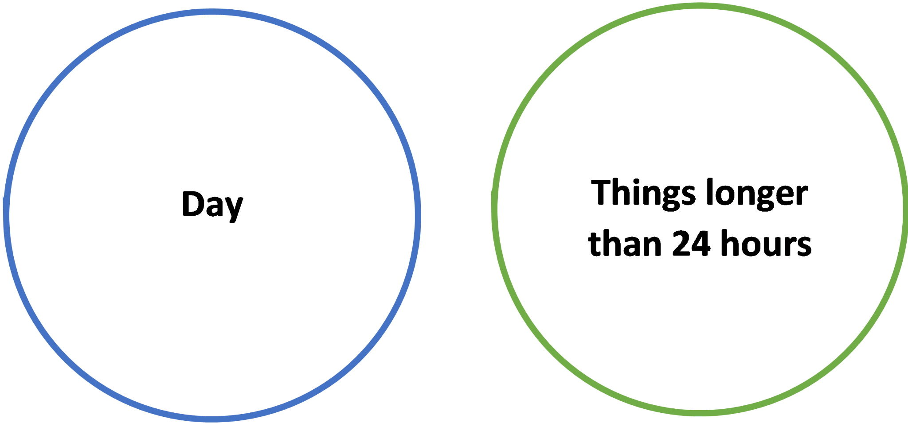
Euler Circles for “No day is longer than 24 hours.” (answers may vary in terms of labelling)

Exercise 6
Answers will vary, but diagrams should look similar to the ones directly above.
Exercise 7
i. Amy is happy.
ii. Amy is not joyful.
iii. Amy is angry.
iv. Amy is not sad.
Exercise 8
- They do not mean the same thing. The first proposition is true only if there is not a single apple that is green. However, the second sentence can still be true if some apples are green, so long as there are also some that aren’t green.
- They mean the same thing.

Lesson 13 Answer Key:
Exercise 1
- Some dogs are not mammals – Particular Negative, false
- Some dogs are butterflies – Particular Affirmative, false
- Some mammals lay eggs – Particular Affirmative, true
- Some mammals don’t lay eggs – Particular Negative, true
Exercise 2 (review)
i.
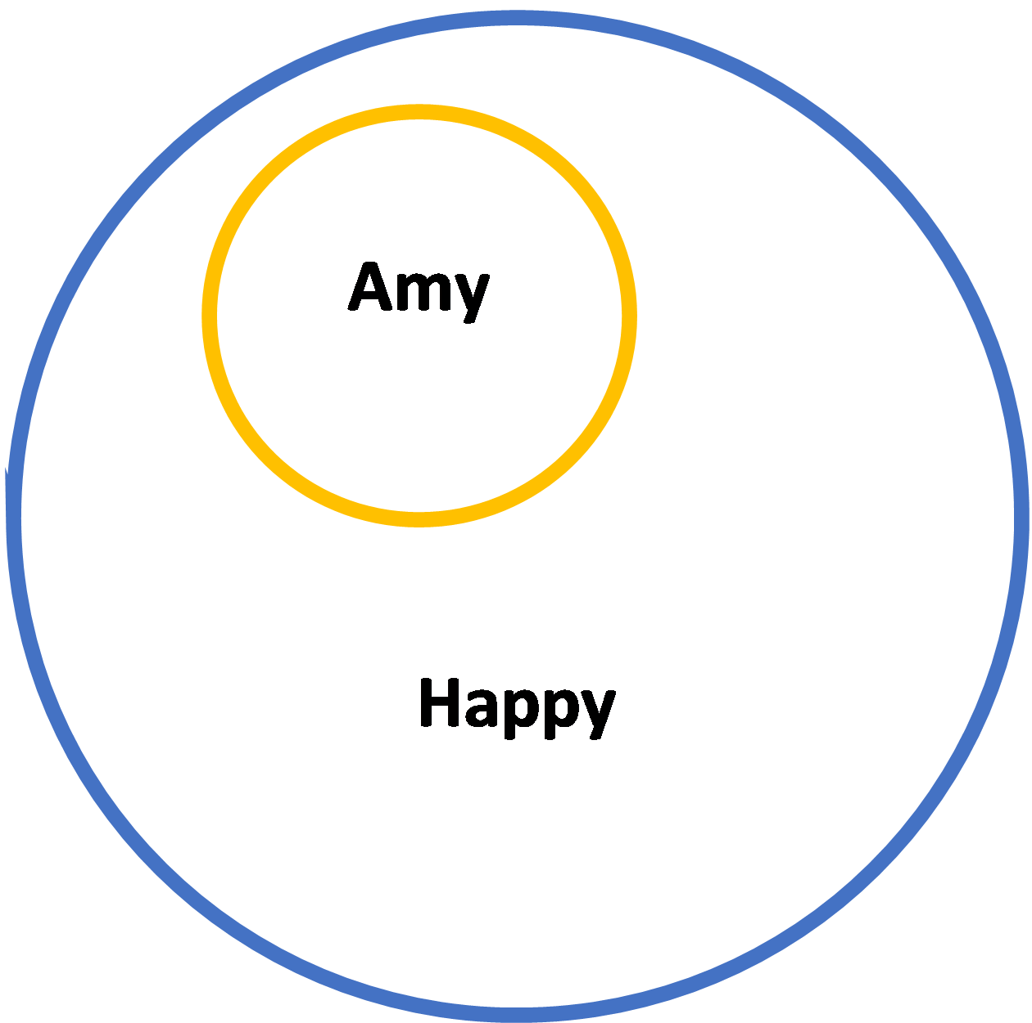
Figure 5: Euler Circles for “Amy is happy.”

ii.
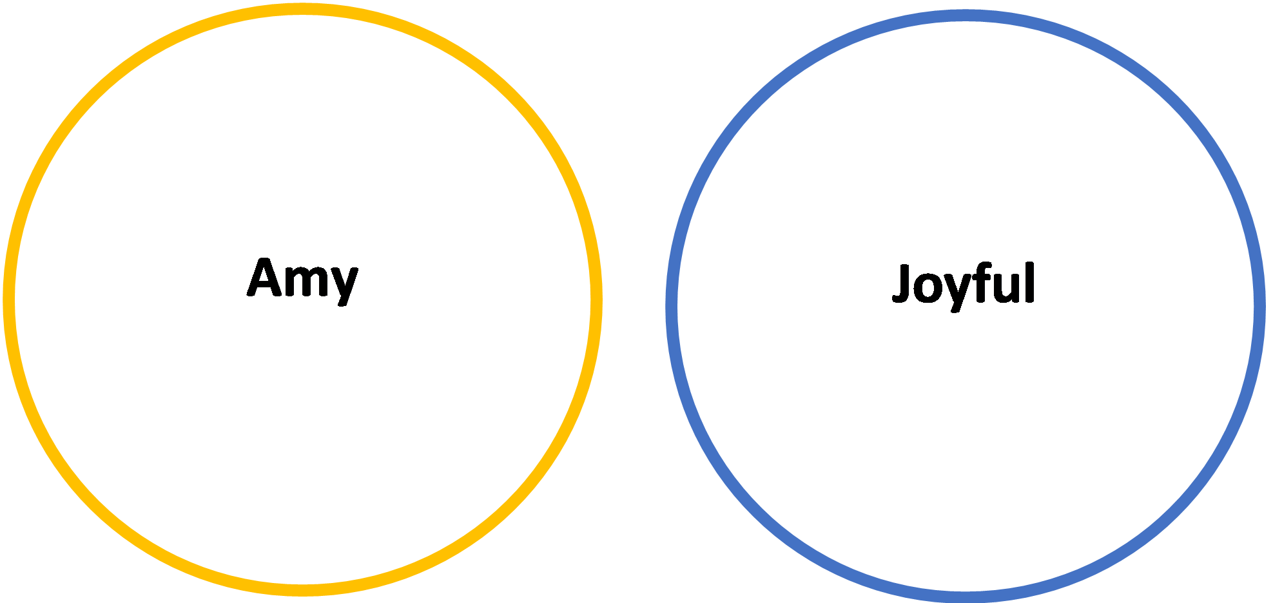
Figure 6: Euler Circles for “Amy is not joyful.”

iii.
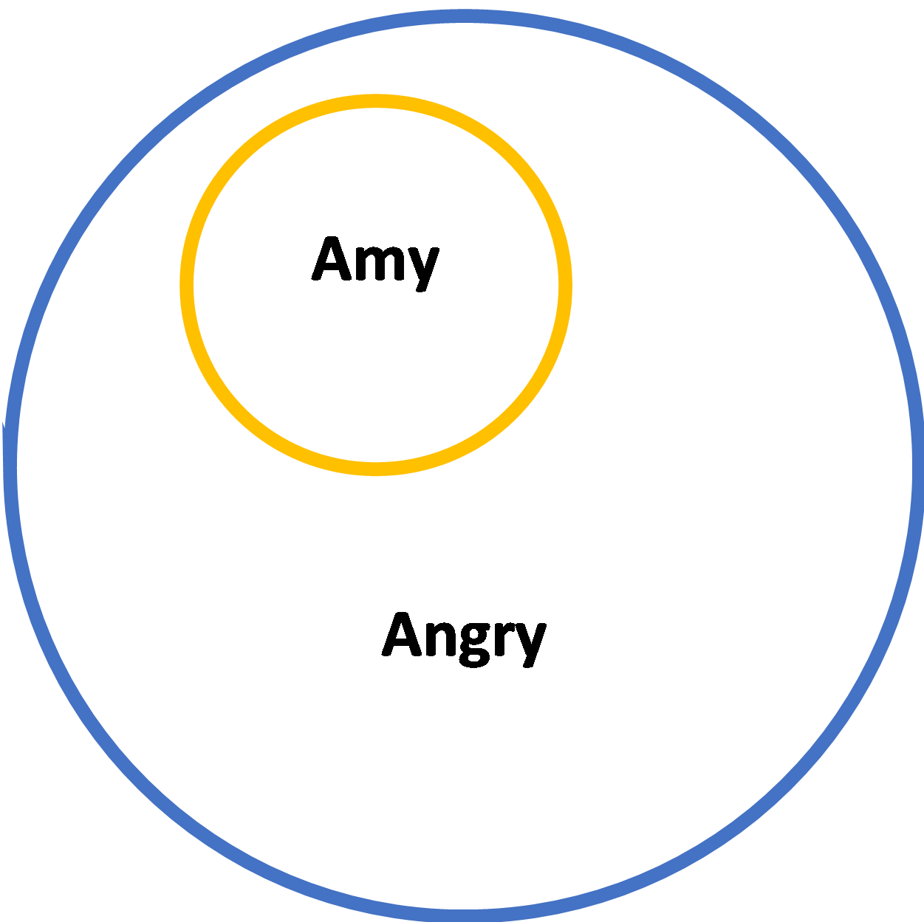
Figure 7: Euler Circles for “Amy is angry.”

iv.
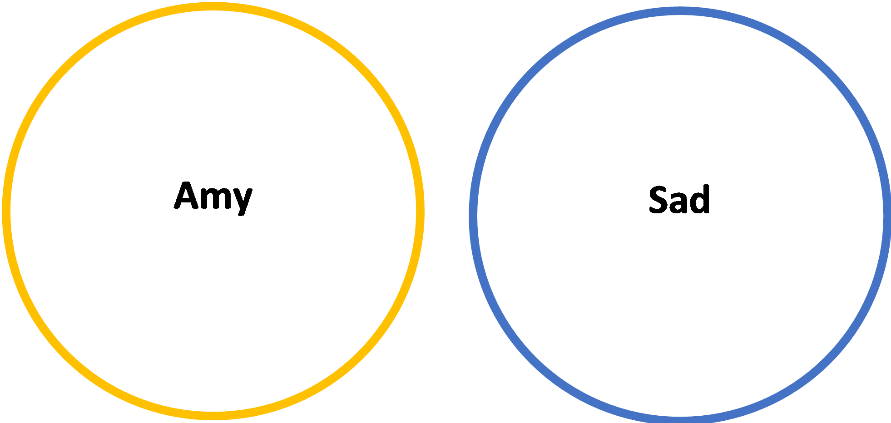
Figure 8: Euler Circles for “Amy is not sad.”

Exercise 3
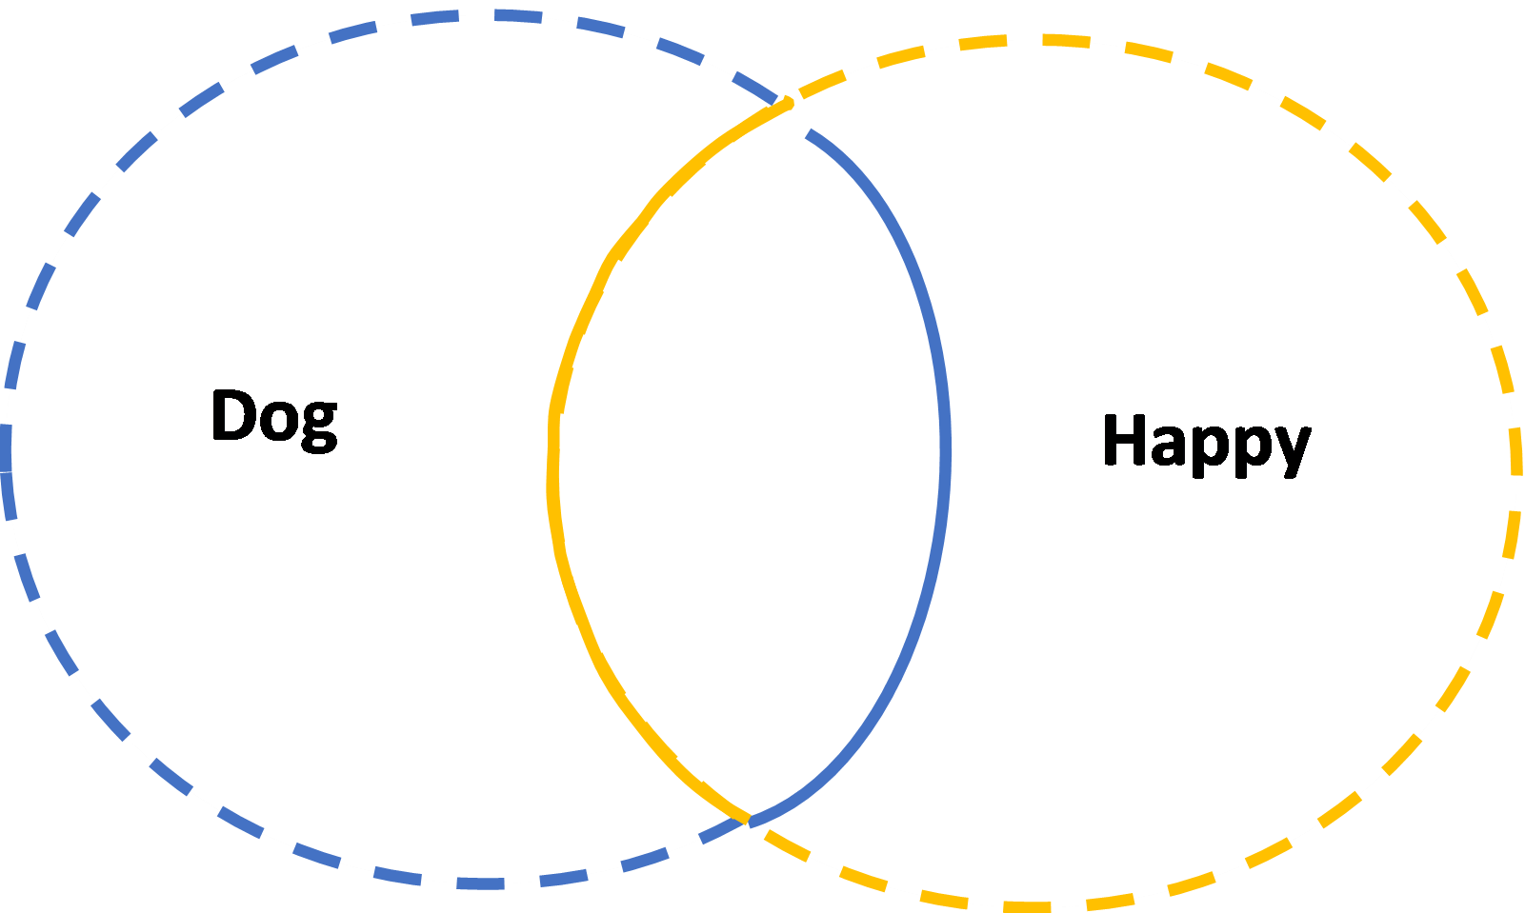
Figure 9: Euler Circles for “Some dogs are happy.”

Exercise 4
Answers will vary, but diagrams should look similar to the ones directly above, with explanations similar to those given in the “Examples” section of this lesson.

Exercise 5
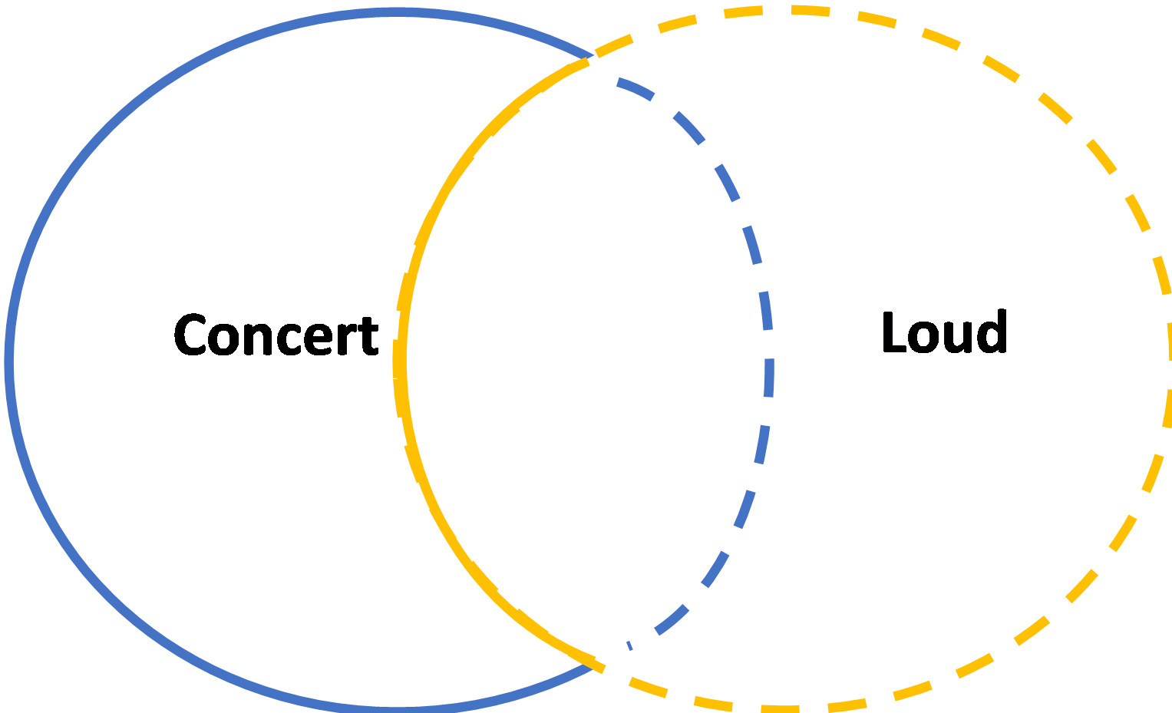

Figure 10: Euler Circles for
“Some concerts are not loud”

Exercise 6
Answers will vary, but diagrams should look similar to the ones directly above, with explanations similar to those given in the “Examples” section of this lesson.

Exercise 7
“Some cats are animals” is an example of a Particular Affirmative proposition that is true. It may initially appear as though it is false because all cats are animals, but we must remember that “some” is a subset of “all.” So, the proposition is technically true, albeit misleading.

Lesson 14 Answer Key:

Exercise 1
- “All dogs are friendly” is a Universal Affirmative proposition. Its contrary would be “no dogs are friendly.” Its subaltern would be “some dogs are friendly.” Its contradiction would be “some dogs are not friendly.” It does not have a subcontrary.
- “Some houses are not expensive” is a Particular Negative proposition. Its subcontrary would be “some houses are expensive.” It does not have a subaltern. Its contradiction would be “all houses are expensive” (or “no houses are not expensive,” which is logically equivalent). It does not have a contrary.
- “Some bumblebees are loud” is a Particular Affirmative proposition. Its subcontrary is “Some bumblebees are not loud.” Its contradiction is “No bumblebees are loud.” It does not have a subaltern. It does not have a contrary.
- “No philosophers are musicians” is a Universal Negative proposition. Its contrary is “All philosophers are musicians.” Its contradiction is that “Some philosophers are musicians.” Its subaltern is “Some philosophers are not musicians.” It does not have a subcontrary.

Exercise 2
Answers may vary. Here is one: Some proposition A is the subaltern of another proposition B if and only if the truth of A implies the truth of B, but not the other way around. We know that universal propositions imply the truth of particular propositions, so we know that particular propositions are the subalterns of universal propositions. However, particular propositions do not imply anything in this way. If we say “some dogs are cute,” we cannot conclude that “all dogs are cute,” nor can we conclude that “some dogs are not cute” or that “no dogs are cute.”

Exercise 3
In a square of opposition, the word “always” would belong in the A corner, corresponding to Universal Affirmative propositions. Its contrary would be “never,” corresponding to Universal Negative propositions. Its subaltern would be “sometimes,” corresponding to Particular Affirmative propositions.

Exercise 4
The propositions “some unicorns have horns” and “some unicorns do not have horns” are not a good example of a subcontrary pair. Given that unicorns do not exist, both propositions are false. However, a subcontrary pair is one in which both propositions cannot be false.

Lesson 15 Answer Key:
Exercise 1
a) (PA) proposition, (chairs, comfortable), both terms are not distributed;
b) (PN) proposition, (numbers, odd), subject is not distributed, predicate is distributed;
c) (UA) proposition, (cup of coffee, warm), subject is distributed, predicate is not distributed;
d) (UN) proposition, (pastries, disagreeable), both terms are distributed;
e) (UA) proposition, (logic problems, enjoyable), subject is distributed, predicate is not distributed;
f) (PN) proposition, (ideas, good), subject is not distributed, predicate is distributed.
Exercise 2
(Circles do not need identical labels -- as long as it is clear what each category is)
a)
b)
c)
d)
Exercise 3
a) (as an example answer) “All strawberries are red” is an A sentence. Through ‘all’, we are referring to the entire extension of ‘strawberry’, so the subject is distributed. Since there are red things that are not strawberries, we are ranging only over a part of the extension of ‘red’, so the predicate is not distributed.
Exercise 4
Universal subjects are always distributed, while particular subjects are always not distributed. Predicates in negative propositions are always distributed, while predicates in affirmative propositions are always not distributed.
Exercise 5
- (UN) proposition b) (UA) proposition c) (PN) proposition d) (PA) proposition
Lesson 16a Answer Key:
Exercise 1
Conjunction: “p and q”

Exercise 2
Answers will vary widely, however the compound propositions must follow the basic form guidelines for the kind of proposition discussed above: “p and q”.
Exercise 3

p | q | “p and q”
True | True | True
False | True | False
True | False | False
False | False | False

Exercise 4
1.) This is true as both conjuncts are true.
2.) Generally, this would be considered false, as only the first of the two propositions is true, however if you interpret the clouds to be a part of the sky, then both propositions are true, so the whole conjunction is true.
3.) Both sides of the conjunction are true, so the proposition as a whole is true.
4.) Both sides of the conjunction are true, so the proposition as a whole is true.
5.) The first proposition is true, though the second is false, so the conjunction is false.

Lesson 16b Answer Key:
Exercise 1
Disjunction: “p or q”

Exercise 2
Answers will vary widely, however the compound propositions must follow the basic form guidelines for the kind of proposition discussed above: “p or q”. Explanations should follow the guidelines about what it means for a disjunctive proposition to use an exclusive “or” versus and inclusive “or.”
Exercise 3
1.
p | q | “p or* q”
True | True | False
False | True | True
True | False | True
False | False | False

2.
p | q | “p or q”
True | True | True
False | True | True
True | False | True
False | False | False

3.
p | q | “p and q”
True | True | True
False | True | False
True | False | False
False | False | False

Exercise 4
1.) This is true under the inclusive disjunction, as both disjuncts are true.
2.) Both disjuncts are false, so the disjunction is false.
3.) This is true under the inclusive disjunction, as both disjuncts are true.
4.) Both disjuncts are false, so the disjunction is false.
5.) The first disjunct is true, though the second is false, so the disjunction is true.

Lesson 16c Answer Key:
Exercise 1
Hypothetical: “If p, then q”

Exercise 2
1.
p | q | “If p, then q”
True | True | True
False | True | True
True | False | False
False | False | True

2.
p | q | “p or q” (exclusive or)
True | True | False
False | True | True
True | False | True
False | False | False

3.
p | q | “p or q” (inclusive or)
True | True | True
False | True | True
True | False | True
False | False | False

4.
p | q | “p and q”
True | True | True
False | True | False
True | False | False
False | False | False

Exercise 3
Answers will vary widely, however the compound propositions must follow the basic form guidelines for the kind of proposition discussed above: “If p, then q”.

Exercise 4
1.) This is true, as both the antecedent and the consequent are true.
2.) Given the truth of both the antecedent and the consequent, this proposition will be true.
3.) This is false, as the antecedent is true, though the consequent is false.
4.) This proposition is of the more confusing form of the hypothetical, since because the consequent is true, regardless of the antecedent, this proposition must be true.
5.) This proposition is true, as Aristotle being the first formal logician implies no formal logician could be born before him.
Exercise 5 (Challenge Question)
1.) This is true as the simple disjunction “Apples are fruit or they are not” has one true disjunct and one false one, so it is true. This will make the conjunction as a whole true, as the other conjunct “all fruits have seeds” is true, so the conjunction has two true conjuncts.
2.) This proposition is false. This can be seen by assuming the truth of the disjunction “a person can swim or float”; once this is assumed, the student should see that being able to swim and being able to float both implies, on their own, that said swimmer or floater will not drown.
3.) This proposition is true as it is a disjunction with one true disjunct and one false one. The first disjunct is a true conjunction, as water is composed of Hydrogen and it is composed of oxygen. The second is a false conjunction, as water is not composed of Helium and it is not composed of Aluminum.

Exercise 6 (Challenge Question)
p | q | r | “If p, then q” | (if p, then q) or r
True | True | True | True | False
True | True | False | True | True
True | False | True | False | True
True | False | False | False | False
False | True | True | True | False
False | True | False | True | True
False | False | True | True | False
False | False | False | True | True

Lesson 18 Answer Key:

Exercise 1
i. False. Which premise is the major or the minor premise depends on whether it contains the subject or the predicate of the conclusion, not on whether it comes first or second in the progression of the syllogism.
ii. True. Validity depends on correct structure, not on the truth or falsity of the premises.
iii. False. The truth or falsity of the conclusion depends on the truth or falsity of the premises in a valid syllogism. (Assuming all terms are clear and unambiguous)

Exercise 2
Fill in the blanks for the following five syllogisms:
i. No mammals are toads. All monkeys are mammals.  No monkeys are toads. | Premises: “No mammals are toads;” “All monkeys are mammals”  Conclusion: “No monkeys are toads”  Minor Term: “monkey”  Major Term: “toad”  Middle Term: “mammal”  Minor Premise: “All monkeys are mammals”  Major Premise: “No mammals are toads”
ii. All houseplants require watering. This fern is a houseplant. This fern requires watering.  Can be reformulated as:  All houseplants are things that require watering. This fern is a houseplant.  This fern is a thing that requires watering. | Premises: “All houseplants are things that require watering”; “This fern is a houseplant”  Conclusion: “This fern is a thing that requires watering”  Minor Term: “This fern”  Major Term: “a thing/things that require watering”  Middle Term: “houseplant”  Major Premise: “All houseplants are things that require watering”  Minor Premise: “This fern is a houseplant”
iii. No lawyers are children. Some immature people are lawyers. Not all immature people are children. | Premises: “No lawyers are children;” “Some immature people are lawyers”  Conclusion: “Not all immature people are children”  Minor Term: “immature people”  Major Term: “children”  Middle Term: “lawyer”  Minor Premise: “Some immature people are lawyers”  Major Premise: “No lawyers are children”
iv. All children are sometimes grouchy. Amy is a child. Amy is sometimes grouchy. | Premises: “All children are sometimes grouchy;” “Amy is a child”  Conclusion: “Amy is sometimes grouchy”  Minor Term: “Amy”  Major Term: “sometimes grouchy”  Middle Term: “child”  Minor Premise: “Amy is a child”  Major Premise: “All children are sometimes grouchy”
v. All elephants have tusks. Some animals are elephants. Some animals have tusks.  Can be reformulated as:  All elephants are things that have tusks. Some animals are elephants.  Some animals are things that have tusks. | Premises: “All elephants are things that have tusks”; “Some animals are elephants”  Conclusion: “Some animals are things that have tusks”  Minor Term: “animal”  Major Term: “things that have tusks”  Middle Term: “elephant”  Minor Premise: “Some animals are elephants”  Major Premise: “All elephants are things that have tusks”

Exercise 3
Answers will vary.

Lesson 19 Answer Key:
Exercise 1
- If p, then q; p; therefore q.
- If p then q; not q; therefore not p.
- The two parts of the hypothetical are the antecedent and the consequent. The antecedent entails the consequent. In other words, the antecedent appears first in the conditional (p), and the consequent appears second in the conditional (q), so that “if p, then q.”
- This is to say that if all of the premises are true, Modus Ponens and Modus Tollens guarantee the truth of the conclusion. In other words, they will always yield a true conclusion if the premises are true.

Exercise 2
- Modus Ponens
- Neither
- Modus Tollens

Exercise 3

- Modus Tollens, hypothetical proposition
- Modus Tollens, only categorical propositions
- Neither
- Modus Tollens, hypothetical proposition
- Modus Ponens, hypothetical proposition
- Neither
- Modus Tollens, hypothetical proposition

Exercise 4
(Premise order may vary)
- (1) Plato is happy
(2) Aristotle is not happy
(3) Therefore, Aristotle is not Plato
- (1) All humans are featherless bipeds.
(2) Diogenes is a human.
(3) Therefore, Diogenes is a featherless biped.
- (1) All chairs are pieces of furniture.
(2) No countries are pieces of furniture.
(3) Therefore, no countries are chairs.

Exercise 5 (Challenge Question)
Answers will vary widely, however two of the arguments provided must follow the outline “If p, then q; p; therefore q”, and the other two must follow the outline “If p then q; not q; therefore, not p”.

Lesson 20 Answer Key:
Exercise 1
- If p, then q; q; therefore p
- If p, then q; not p; therefore, not q
- A fallacy is a mistake in reasoning, which denies the truth of any conclusions reached using said reasoning. (Answers may vary slightly)

Exercise 2
- This is not fallacious.
- This is fallacious; to correct this, one would need to change the first premise. The substituted premise will be “if the Los Angeles Lakers win the NBA title, none of the Lakers’ fans will cry”. This is Denying the Antecedent.
- This is fallacious; to correct this, one would need to change the first premise. The substituted premise will be “if I don’t wear my jade earrings, I won’t feel cool”. This is Denying the Antecedent.

Exercise 3
- Denying the Antecedent, only categorical propositions
- Neither
- Neither
- Affirming the Consequent, hypothetical proposition
- Neither
- Affirming the Consequent, only categorical propositions
- Denying the Antecedent, hypothetical proposition
Exercise 3 (Challenge Question)
- Denying the Antecedent
- Modus Tollens
- Affirming the Consequent

Lesson 28 Answer Key:
Exercise 1
Answers may vary. However, some examples of suitable answers will be presented below.
1. The ontological version states that it is impossible for the same subject(s) to possess
opposite properties in the same way at the same time.
2. The doxastic version states that it’s impossible to (rationally) belief contradictory
propositions simultaneously.
3. The semantic version states that a proposition and its contradiction cannot both be true
at the same time.

Exercise 2
1. This doesn’t violate the principle, as the elder did not possess the properties at the same
time.
2. The psychological interpretation makes a claim about the capabilities of the human
mind, while the normative interpretation makes a claim about rationality.
3. This is fair to say, as the true of propositions is reliant upon the state of the actual
exterior world.

Exercise 3 (Challenge Question)
1. This does violate the doxastic principle, as the fossil fuel industry has a negative impact on the climate crisis, so it is not rational to believe the former is fine while also believing the
latter is a pressing issue, recognition of the pressing nature of the climate crisis implies
recognition of the moral failings of the fossil fuel industry.
2. This could be thought to violate the principle depending on whether or not being
beautiful/ugly is thought of as a relative property that depends on the speaker. If it is, then the subjective nature of the propositions will make both be simultaneously true, and the ontological Principle of Non-Contradiction will be violated. If the property is thought of as absolute, then one of the propositions will be false, and the principle will not be violated.
3. This does not violate the ontological principle, because the fact that this person is a “well known liar” does not mean that they are lying at this moment; in the same vein this does not mean that they are no longer a “well known liar”. This does not violate the semantic version, as the situation described provides no reason to think that the statement is not determinately true or false.

Lesson 29 Answer Key:

Exercise 1
Two important pieces of information that we can gather from the identity principle are (1) when a pair of terms are equivalent (i.e. when their referents share all the same characteristics), and (2) when a pair of terms are not equivalent (i.e. when their referents don’t share all the same characteristics).

Exercise 2
i. “Bike” and “scooter” are not equivalent terms.

The characteristics of the referents of the terms “bike” and “scooter” are different. Bikes have pedals, scooters don’t; bikes are ridden sitting down, scooters are ridden standing up, etc. By the identity principle, we know that two terms whose referents have different characteristics cannot be equivalent.

ii. “Tennis shoes” means the same thing as “sneakers.”

The fundamental characteristics of the referents of the terms “tennis shoes” and “sneakers” are the same. They have laces and rubber soles, can be used for sports, etc. By the identity principle, we know that two terms whose referents have all the same characteristics must be equivalent.

iii. A lawyer is someone who has the authority to interpret the law.

We know that the phrase “someone who has the authority to interpret the law” is the definition of the term “lawyer” Therefore, we can conclude that the referent of the phrase “someone who has the authority to interpret the law” and the referent of the term “lawyer” have all the same characteristics. Given the identity principle, this means that the phrase and the term must be equivalent.
iv. One should not compare apples and oranges.

The fundamental characteristics of apples and those of oranges are different. Apples are smooth whereas oranges are textured; apples have a core whereas oranges have pulp; apples have thinner skins than oranges, et. By the identity principle, we know that things with different characteristics are different. It’s because apples and oranges are different that we shouldn’t compare them.

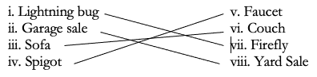
Exercise 3

Exercise 4
i. “The Sun” satisfies the identity principle for the phrase “the star closest to Earth.”
ii. “Mars” satisfies the identity principle for the phrase “the fourth planet from the Sun.”
iii. “George Washington” satisfies the identity principle for the phrase “the first president of the United States.”
iv. “Russia” satisfies the identity principle for the phrase “the largest country in the world.”
v. “Aristotle” satisfies the identity principle for the phrase “Plato’s most famous student.”

Exercise 5
Angela is *hip.*
*Hips* don’t lie!
Therefore, Angela doesn’t lie.

This syllogism violates the identity principle because the term “hip” is used in the first premise to denote being cool, whereas it is used in the second premise to denote a body part. Although the argument purports to use “hip” consistently across the two premises, it is actually conflating two different referents. Therefore, the same identity is not being maintained.

Lesson 30 Answer Key:
Exercise 1
The principle of excluded middle targets pairs of contradictory opposites, stating that at least one of them must be true. The principle of bivalence targets individual propositions, stating that they must be either true, or false.

Exercise 2
i. a) by PEM; e) by the principle of identity; g) by PNC; ii. a) by PEM; g) by PNC; iii. a) by the principle of identity; b) by the principle of identity; c) by PEM.

Exercise 3
We leverage both PEM, and PNC in a proof by contradiction. If we have to prove P by contradiction, the first step is noting that either P, or not-P – PEM itself. If assuming not-P leads to a contradiction, then, by PNC, not-P is false. By PEM, since at least one proposition must be true, it follows that P must be true.
Exercise 4
i. PEM; ii. neither; iii. PEM; iv. the principle of bivalence; v. neither; vi. the principle of bivalence.

Exercise 5
Negating PEM twice, we obtain “It is not the case that it is not the case that either P, or not-P.” It must be that “It is not the case that either P, or not-P” is false, so that negating it again yields a truth. For any truth-value of P, one of the disjuncts will be true and the other false, so the disjunction will be true and its negation will always be false. In other words, this amounts to saying “Both P, and not-P.”, a statement which is always false for every truth-value of P. Putting this together with our previous result, we obtain “It is not the case that both P, and not-P.”, which is the given form of the PNC.

